M1.2 Assignment
Course: CSD310 – 340A
Prepared By: Mirach Erkol
Date of Report: 10/26/2025

M1.2 Assignment:

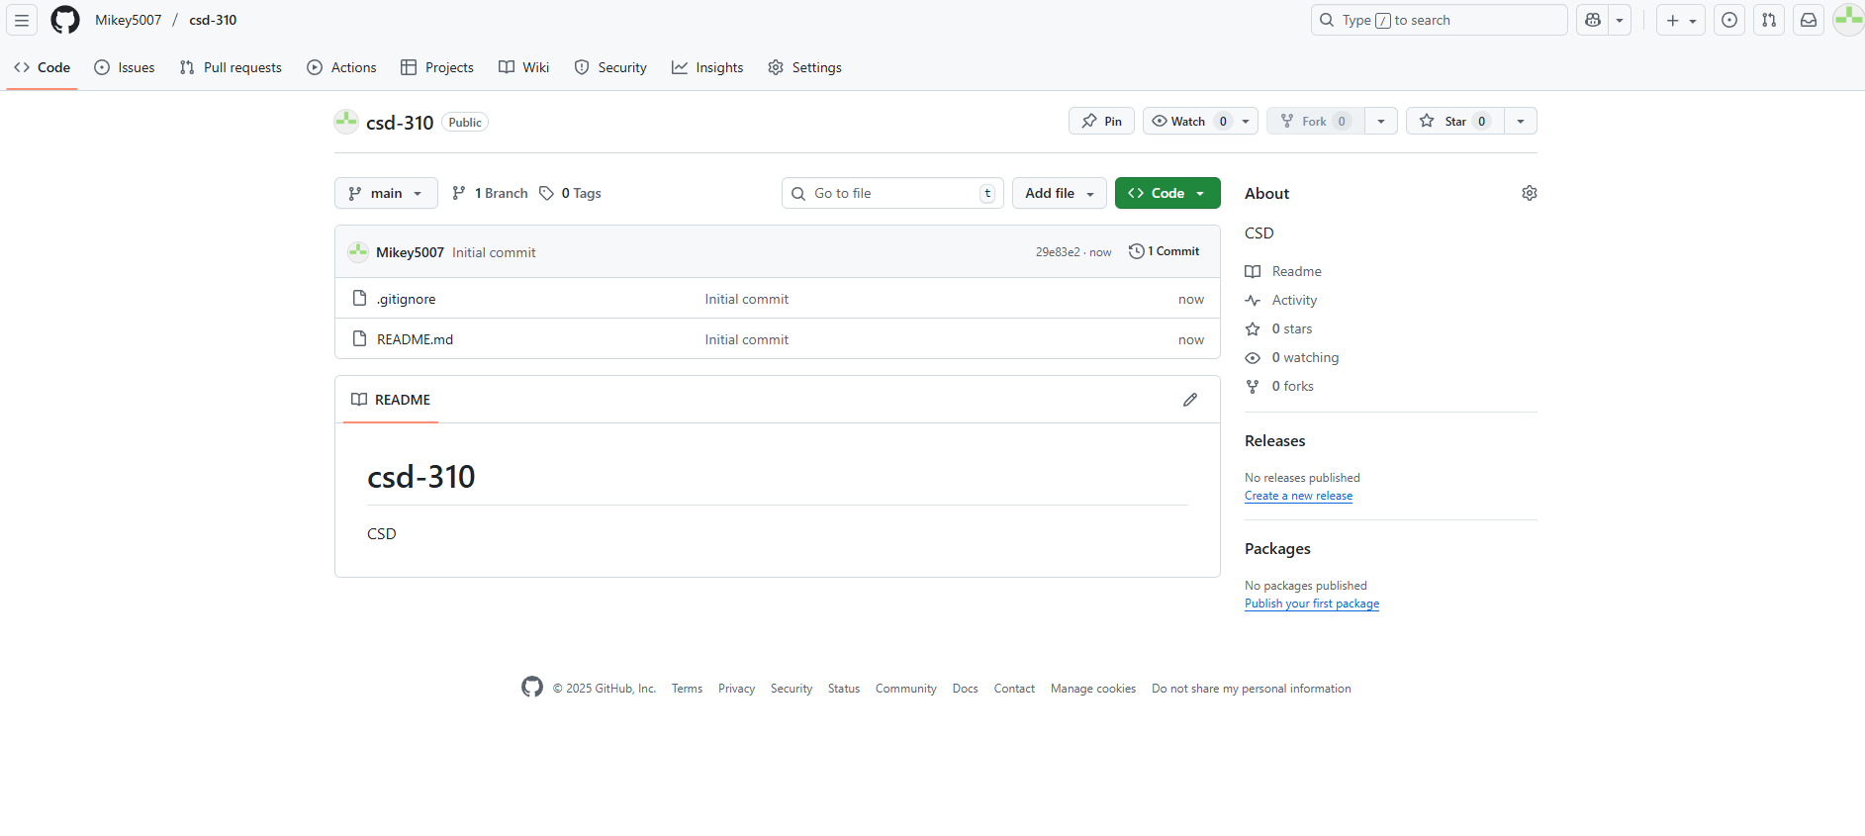
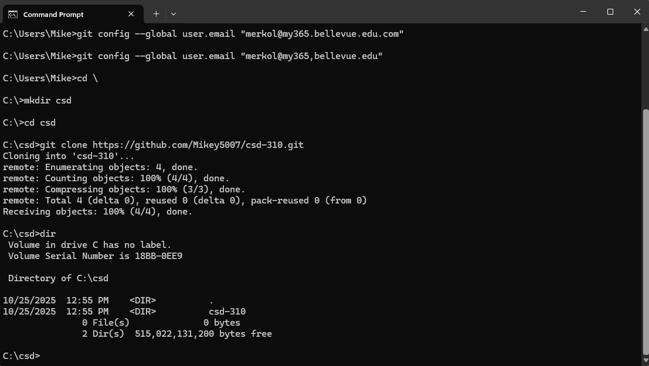

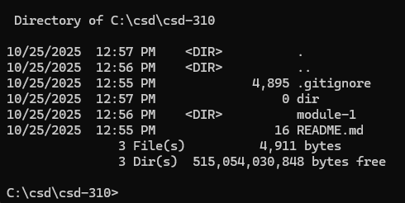
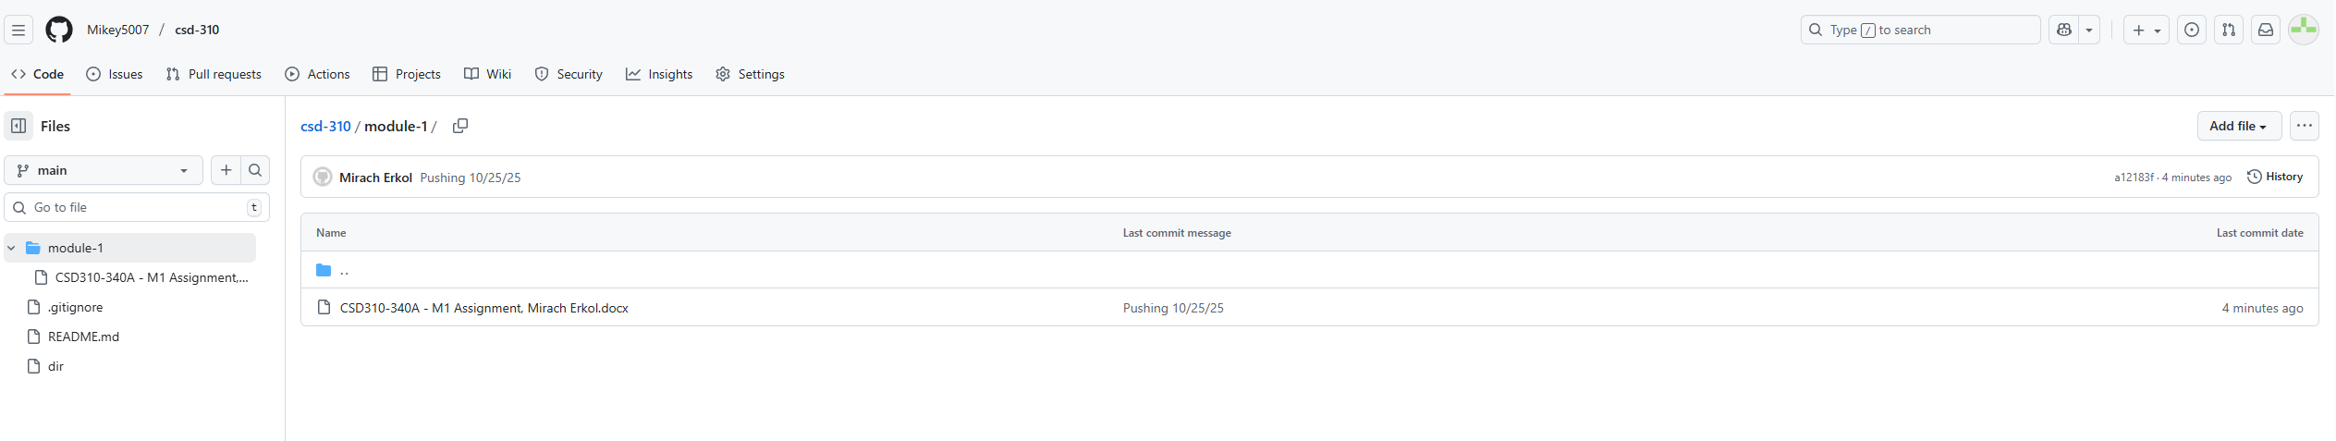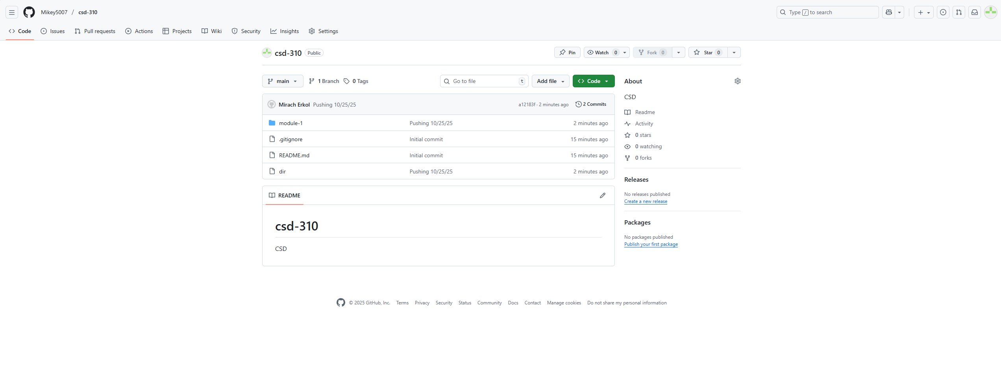
Mikey5007/csd-310: CSD

